Insert logo here

Centre Name

2XXX-2XXX
Template Student
Code of Conduct
Equity and Excellence: realising the potential of every student
Equity and Excellence outlines the government's vision for a progressive, high-performing education system. Equity and Excellence provides clarity for schools about priorities and expectations, with differentiated support targeted to each school's context and needs.
Queensland Department of Education

Note 1. This prompt guide is designed to assist in the development of the Student Code of Conduct.

Note 2. The Student Code of Conduct must be developed in consultation with the centre community, and a communication plan implemented to ensure existing and new staff, students and parents are fully informed of the expectations and disciplinary strategies in place at your centre.

Note 3 A copy of the current, signed Student Code of Conduct must be published on the landing page of the centre website. Instructions for this purpose are available from your regional office.

Note 4. Centres must arrange to provide a hard copy of the Student Code of Conduct on request, to a parent, carer or a person who is responsible for a student at the centre.

Note 5. Please ensure that all RED text is deleted before converting to PDF and publishing the signed version on the centre’s website.

Purpose (Mandated)

Describe what the Student Code of Conduct is for, what it covers and how it supports consistent practice across the centre.

Contact Information (Mandated)

Postal address:
Phone:
Email:
Centre website address:
Contact Person: | Title of a contact person for further information on the centre and its behaviour policies, including reporting bullying.

Endorsement (Mandated)

Principal Name:
Principal Signature:
Date:

Contents (Mandated)

Table of contents with headings and page numbers.

Whole School Approach to Discipline (Mandated)

In this section, provide a clear explanation of the whole-school approach to student discipline. This could include explanation of the philosophical position on child development assumed by centre staff, the role of teachers in creating and maintaining supportive and safe learning environments, and the way collaborative relationships with parents are established and promoted.

It is recommended that schools draw on the Australian Professional Standards for Teachers – Standard 4 when preparing this overview (covering student participation, managing classroom activities, managing challenging behaviour, maintaining student safety and using ICT safely, responsibly and ethically).

This section also provides another opportunity for the centre to explain how a student’s individual circumstances, such as the student’s behaviour history, disability, mental health and wellbeing, religious and cultural considerations, home environment and care arrangements are taken into account when responding to inappropriate behaviour and applying a disciplinary consequence. This should cover how OneSchool records are used, such as Personalised Learning and Support Provisions, to document supports.

Consideration of Individual Circumstances (Mandated)
Detail how the individual circumstances of students are considered by staff when providing support and determining appropriate consequences for disciplinary matters.

Ensure information is included about confidentiality obligations limiting discussion or sharing information about individual circumstances of students, including applied disciplinary consequences, with persons other than the student’s parent/s.

Differentiated and Explicit Teaching (Mandated)

Explain the relationship between differentiation, as detailed in the Assessment and Moderation Hub’s Differentiated teaching and learning, and the centre’s discipline model. This could be the section where further detail about how the individual needs or circumstances of students are addressed through reasonable adjustments to teaching, curriculum and assessment. A clear explanation of the three levels of differentiation, differentiated and explicit teaching, focused teaching and intensive teaching as they apply to supporting student behaviour.

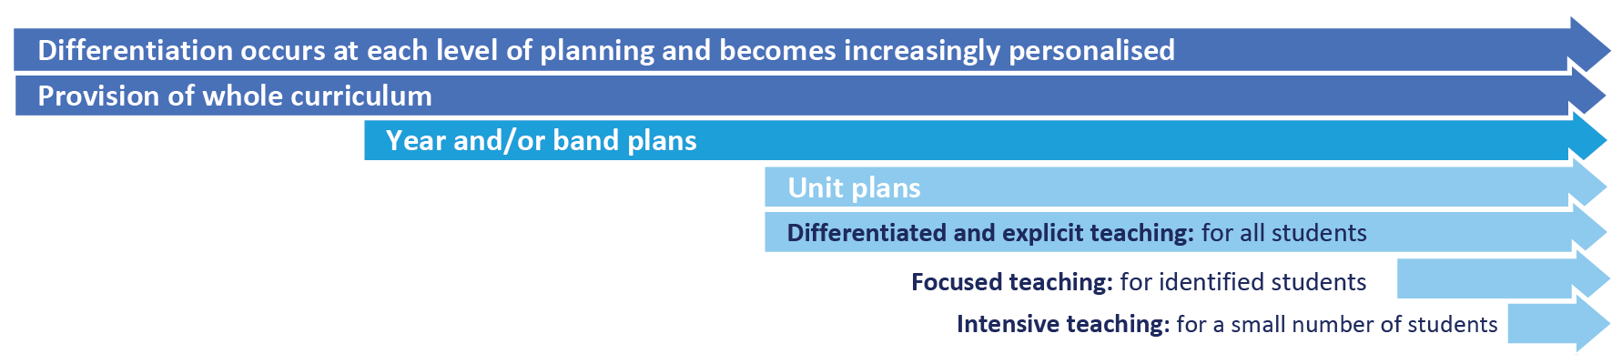

Focused Teaching

Detail the focused teaching provided including additional support to revisit key behavioural concepts and/or skills and explicit and structured teaching strategies. Focused teaching provides students with more opportunities to practise skills and multiple opportunities to achieve the intended learning and expected behaviour.

Intensive Teaching

Unpack the intensive teaching supports involving frequent and explicit instruction for individuals or in small groups, to develop mastery of basic behavioural concepts, skills and knowledge.

For example, a small number of students who continue to display behaviours that are deemed complex and challenging, then individualised, function-based behaviour assessment and support plans and multi-agency collaboration may be provided to support the student.

Disciplinary Consequences (Mandated)

In this section, after consultation with staff, students and the broader community, the centre’s system of possible consequences for unacceptable behaviour is detailed. There should be no suggestion or indication in the Student Code of Conduct that any specific behaviour will automatically result in a particular disciplinary consequence, for example that smoking on centre will result in exclusion. This goes against the principles of natural justice that all principals are required to adhere by in their decision-making. Similarly, principals should take care to avoid suggesting or implying that there is a ‘three-strikes’ rule in effect. Each situation needs to be dealt with and given due consideration.

The description of the consequences system should include:
- consequences that are logically tied to the problem behaviour
- a focus on the use of consequences to teach students appropriate ways to meet their needs
- use of behavioural data to evaluate the effectiveness
- consistency in the administration of consequences by staff
- evidence that all staff have collaborated in designing the system and that they are in broad agreement with its deployment
- agreed procedures which involve the placement of students away from the classroom, i.e. detention and time out, which are consistent with the provisions of the Student discipline procedure
- the centre’s approach to re-entry following suspension if applicable.

Centre Policies (Mandated)
In this section, provide copies of any specific centre discipline policies designed to ensure all staff work consistently to create and maintain a supportive and safe learning environment. At a minimum, each centre has a policy on each of the following:

- Temporary removal of student property (Mandated)
- Use of mobile phones and other devices by student (Mandated)
- Preventing and responding to bullying (Mandated)
- Appropriate use of social media (Mandated)

Temporary removal of student property (Mandated)

- The removal of any property in a student’s possession may be necessary to promote the caring, safe and supportive learning environment of the centre, to maintain and foster mutual respect between all centre staff, students and visitors. Ensure this section of the Student Code of Conduct clearly details information about the Temporary removal of student property by school staff procedure, including:
  - a clear explanation of the items considered inappropriate to bring to centre
  - that centre staff may in certain circumstances remove student property without the consent of parents or students
  - the limits on centre staff searching bags and accessing information from temporarily removed student property, such as mobile phones
  - examples of property that may be temporarily removed, such as bags, mobile phones, jewellery or prohibited items such as knives
  - examples of the amount of time certain property may be temporarily removed (e.g. end of day or week)
  - that student property may be seized by the police.

Please see Temporary removal of student property by school staff procedure for more information.

Use of mobile phones and other devices by students (Mandated)

This local centre policy must provide clear expectations for parents and students about what devices are allowed at the centre, how they are to be used and the possible consequences for failing to meet the stated expectations. It is recommended that clear guidance be provided on the centre’s position regarding:
- mobile phones
- tablet, slate or laptop computers
- wearable technology or sensing devices

Some examples of different requirements settingss, in consultation with their community, might consider in applying to the access and use of mobile phones include:
  - phones to be turned on to silent mode and out of sight or switched off in the classroom (unless given explicit permission to use them);
  - phones to be placed in a safe place in the room when students arrive for class;
  - phones to be handed in/picked up from a particular location before and after day activities are completed;
  - students to use mobile phone lockers to store phones during the day;
  - students to only use their mobile phones before and after the day activities are completed or at break times;
  - students not to bring mobile phones to the centre.

Schools should also include reference to the Advice for state schools on acceptable use of ICT facilities and devices, and may wish to include student and parent ICT agreements as part of the Student Code of Conduct. It is also recommended that the guidance developed in this section of the Student Code of Conduct is based on the Use of IT systems procedure.

It is also recommended that communities give consideration to technology-free spaces and times, and that this information is explained in this part of the Student Code of Conduct.
Preventing and responding to bullying (Mandated)

This section of the Student Code of Conduct is required to detail the following:
- description of how the centre actively and explicitly promotes social and emotional competencies among students
- the whole centre program in effect to prevent and address bullying, including links to the independent research-based evaluation conducted to inform its selection (centres are recommended to combine the use of the Be You Programs Directory and STEPS – a decision-making tool to help centres select appropriate and evidence-based anti-bullying programs)
- the professional development program for staff in recognising and responding to bullying, including cyberbullying
- clear reporting procedures for students who observe or experience bullying, including cyberbullying (including flowcharts for students, teachers and parents)
- threshold for reporting to police and or child protection services for bullying, including cyberbullying matters
- possible disciplinary consequences for students who engage in bullying behaviour
- support available for students who have been subjected to or exposed to bullying behaviour by other students
- a compact with students and parents about the single point of contact at the centre who will have responsibility for managing bullying investigations and reporting back to students and parents on outcome (including timeline commitments)
- the centre complaints management process for addressing outstanding matters relating to bullying, including cyberbullying.

Bullying response flowchart for teachers
Please note these timelines may be adjusted depending on the unique circumstances and risk associated with each situation. This is at the professional judgment of the staff involved. Timeframes should be clearly discussed and agreed with student and family.
Template timeframes to be adopted/adapted as necessary to address local context
Key contacts for students and parents to report bullying:
Prep to Year 6 – Class teacher
Year 7 to Year 12 – Form teacher or Year Level Coordinator
Dean of Students – Malcolm Smith, 07 5555 5555

First hour
Listen
- Provide a safe, quiet space to talk
- Reassure the student that you will listen to them
- Let them share their experience and feelings without interruption
- If you hold immediate concerns for the student's safety, let the student know how you will address these. Immediate in this circumstance is where the staff member believes the student is likely to experience harm (from others or self) within the next 24 hours
- Continue to check in with student on regular basis until concerns have been mitigated
- Record notes of follow-up meetings
- Refer matter to specialist staff within 48 hours if problems escalate
- Look for opportunities to improve centre wellbeing for all students
Ongoing
Follow up
- Evaluate the information to determine if bullying has occurred or if another disciplinary matter is at issue
- Make a time to meet with the student to discuss next steps
- Ask the student what they believe will help address the situation
- Provide the student and parent with information about student support network
- Agree to a plan of action and timeline for the student, parent and yourself
Day three
Discuss
- Ask the student for examples they have of the alleged bullying (e.g. hand written notes or screenshots)
- Write a record of your communication with the student
- Check back with the student to ensure you have the facts correct
- Create a record
- Notify parent/s that the issue of concern is being investigated
Day one
Document
- Gather additional information from other students, staff or family
- Review any previous reports or records for students involved
- Make sure you can answer who, what, where, when and how
- Clarify information with student and check on their wellbeing
Day two
Collect
- Document the plan of action
- Complete all actions agreed with student and parent within agreed timeframes
- Monitor the student and check in regularly on their wellbeing
- Seek assistance from student support network if needed
Day four
Implement
- Meet with the student to review situation
- Discuss what has changed, improved or worsened
- Explore other options for strengthening student wellbeing or safety
- Report back to parent
- Record outcomes
Day five
Review
Appropriate use of social media (Mandated)

The department acknowledges the growing popularity of social media both as a communication and educational tool and supports its appropriate use. It also acknowledges the potential for damage to be caused (either directly or indirectly) to students, families and staff through the inappropriate use of social media. Students must understand they are responsible for the content they publish on social media platforms so it is important they understand what is expected of them while using social media. This section of the Student Code of Conduct should clearly detail what behaviour is expected of students, how this will be reinforced and possible consequences for failing to meet these standards.

It is also advisable for centres to consider including information about cybersafety and reputation management in this section of the Student Code of Conduct, including a flowchart about how incidents are managed.

Cyberbullying response flowchart for centre staff

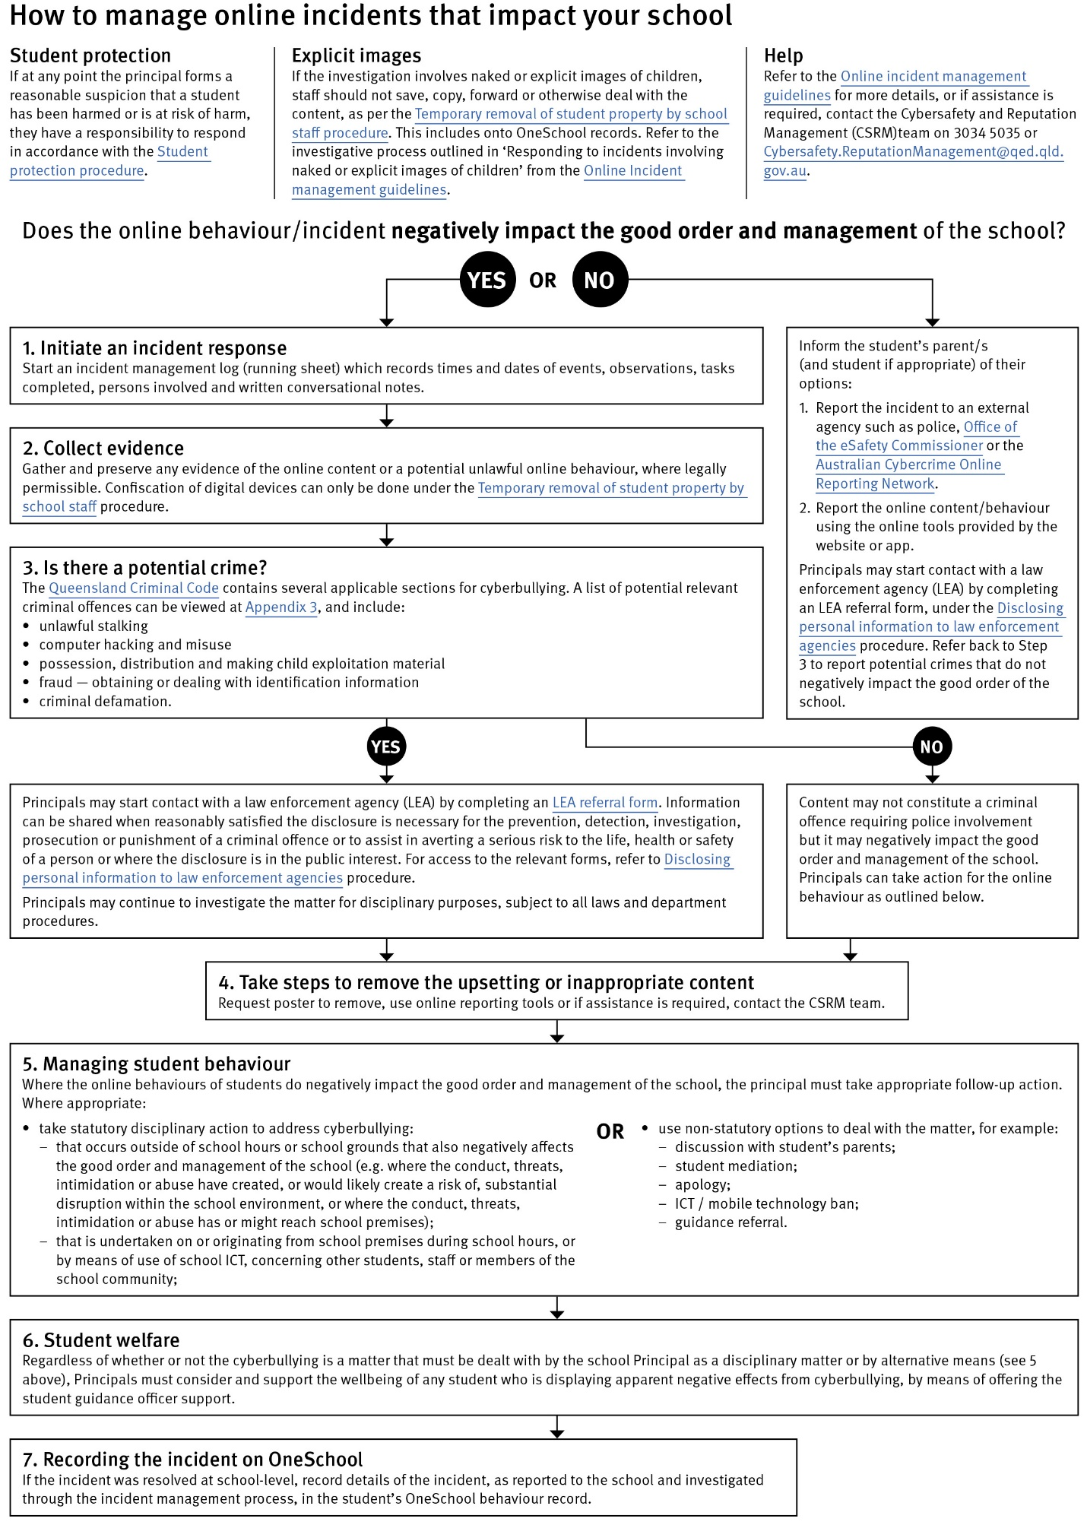

Restrictive Practices (Mandated)
In some very rare situations, where there is immediate risk of physical harm to the student or other people, and when all other alternative strategies have failed to reduce the risk, it may be necessary for staff to use restrictive practices.

The use of restrictive practices will always be as a last resort, when there is no other available option for reducing immediate risk to the student, staff or other people. Restrictive practices are not used for punishment or as a disciplinary measure.

The department’s Restrictive practices procedure is written with consideration for the protection of everyone’s human rights, health, safety and welfare. There are six fundamental principles:

- Regard to the human rights of those students
- Safeguards students, staff and others from harm
- Ensures transparency and accountability
- Places importance on communication and consultation with parents and carers
- Maximises the opportunity for positive outcomes, and
- Aims to reduce or eliminate the use of restrictive practices.

Very rarely restrictive practices will be planned and staff will employ, when necessary, pre-arranged strategies and methods (of physical restraint/ mechanical restraint/ clinical holding) which are based upon behaviour risk assessment or clinical health need and are recorded in advance. The use of planned strategies will only be where there is foreseeable immediate risk consistent with the Restrictive practices procedure.

Seclusion will not be used as a planned response and will only be used in serious circumstances for managing an unforeseeable situation in an emergency. It will be used for the shortest time possible and in a safe area that presents no additional foreseeable risk to the student. In such emergencies, a staff member will observe the student at all times and seclusion will cease as soon as possible.

Following the use of any restrictive practice, a focused review will help staff to understand how they responded to the risk in any incident that involved the use of a restrictive practice. Staff will consider whether there are other options for managing a similar situation in the future. This strategy works well for reducing the use of restrictive practices.

All incidents of restrictive practices will be recorded and reported in line with departmental procedures.

This section of the Student Code of Conduct should include examples of when your centre intends to use any restrictive practices. Please refer to the Restrictive practices procedure in preparation of this element of the document.

Critical Incidents (Mandated)

It is important that all centre staff have a consistent understanding of how to respond in emergencies that seriously endanger students or others. This consistency ensures that appropriate actions are taken to ensure that both students and staff are kept safe.

A critical incident is defined as an occurrence that is sudden, urgent, and usually unexpected, or an occasion requiring immediate action (e.g. in the community, on the road).

This section of the Code of Conduct must detail the actions staff and students will take in the event of a critical incident.

