Insert logo here

Ocean Outdoor Environmental Education Centre

2020-2023
Student
Code of Conduct
Equity and Excellence: realising the potential of every student
Equity and Excellence outlines the government's vision for a progressive, high-performing education system. Equity and Excellence provides clarity for schools about priorities and expectations, with differentiated support targeted to each school's context and needs.
Queensland Department of Education

Purpose

Ocean Outdoor Education Environmental Centre is committed to providing a safe, respectful and disciplined learning environment for all students, staff, parents and visitors.

The Ocean Outdoor Education Environmental Centre Student Code of Conduct sets out the responsibilities and processes we use in our setting to promote a productive, effective approach to discipline.

Its purpose is to facilitate high standards of behaviour from all in the centre community, ensuring learning and teaching in our centre is prioritised, where all students are able to experience success and staff enjoy a safe workplace.

Our staff at Ocean Outdoor Education Environmental Centre work closely with the leadership teams from other schools to ensure visiting students are held to a consistently high standard of behaviour is upheld at all times. Decisions about student discipline will be made in consultation with the student’s school principal or delegate.

Contact Information

Postal address: | 123 Ocean Dam Road Ocean QLD 4310
Phone: | 07 0000 0000
Email: | info@email address
Website address: | https://website address
Contact Person: | Ms Principal Person

Endorsement

Principal Name: | Ms Principal Person
Principal Signature:
Date:

Contents

Whole School Approach to Discipline

Ocean Outdoor Environmental Education Centre operates under the belief that for effective teaching and learning to occur, appropriate relationships must be developed. Students are encouraged to strive for an acceptable level of ‘maturity’ and accept responsibility for their own behaviours.

The behaviours of visiting students, visiting staff, and centre staff are affected by a wide array of societal values and beliefs. Each individual has personal rights and responsibilities which affect the nature of their relationships with others. There is a recognised joint responsibility between the individual (and their family) and the education system (the school and the centre) for their physical, intellectual, emotional and social development. It is acknowledged that the education system has a responsibility to systematically plan for learning experiences that further develop attitudes, values and beliefs that are in accord with those generally accepted in our society.

Ocean OEC focuses teaching, learning and community living experiences on these four student responsibilities:
- Respect
- Safety
- Participation and
- Cooperation.

Queensland state school students who access Ocean Outdoor Environmental Education Centre are not enrolled at our centre, and therefore remain subject to the Student Code of Conduct from their base school. This includes possible disciplinary consequences for inappropriate behaviour such as suspension. Decisions regarding suspension remain the responsibility of the principal of the school at which the student is enrolled.

Consideration of Individual Circumstances

Staff at Ocean Outdoor Environmental Education Centre take into account students’ individual circumstances, such as their behaviour history, disability, mental health and wellbeing, religious and cultural considerations, home environment and care arrangements when teaching expectations, responding to inappropriate behaviour or applying a disciplinary consequence. Our staff, however, rely on the advice and information shared by the student’s parents and staff from the school at which they are enrolled. To ensure that appropriate considerations and reasonable adjustments are made to support each student, it is imperative that information disclosure is proactive to maximise the opportunity for success.

In considering the individual circumstances of each student, we recognise that the way we teach, the support we provide and the way we respond to students will differ. This reflects the principle of equality, where every student is given the support they need to be successful. This also means that not everyone will be treated the same, because treating everyone the same is not fair. For example, some students need additional support to interpret or understand an expectation. Others may benefit from more opportunities to practise a required skill or behaviour. For a small number of students, the use of certain disciplinary consequences may be considered inappropriate or ineffective due to complex trauma or family circumstances. These are all matters that our teachers and principal consider with each individual student in both the instruction of behaviour and the response to behaviour.

Our teachers are also obliged by law to respect and protect the privacy of individual students, so while we understand the interest of other students, staff and parents to know what punishment another student might have received, we will not disclose or discuss this information with anyone but the student’s family. This applies even if the behavioural incident, such as bullying, involves your child. You can be assured that centre staff take all matters, such as bullying, very seriously and will address them appropriately. We expect that parents and students will respect the privacy of other students and families.

If you have concerns about the behaviour of another student at Ocean Outdoor Environmental Education Centre, or the way our staff have responded to their behaviour, please make an appointment with the principal to discuss the matter. Alternatively, please raise your concerns with the principal of the school at which your child is enrolled.

Differentiated and Explicit Teaching

Ocean Outdoor Environmental Education Centre, like all other Queensland state schools, is a disciplined educational environment that provides differentiated teaching to respond to the learning needs of all students. This involves teaching expected behaviours and providing opportunities for students to practise these behaviours. Teachers reinforce expected behaviours, provide feedback and correction, and opportunities for practise.

In collaboration with staff visiting from other schools, teachers at Ocean Outdoor Environmental Education Centre vary what students are taught, how they are taught and how students can demonstrate what they know as part of this differentiated approach to behaviour. These decisions about differentiation are made in response to data and day-to-day monitoring that indicates the behavioural learning needs of students. This enables our teachers to purposefully plan a variety of ways to engage students; assist them to achieve the expected learning; and to demonstrate their learning.

There are three main layers to differentiation, as illustrated in the diagram below. This model is the same used for academic and pedagogical differentiation.

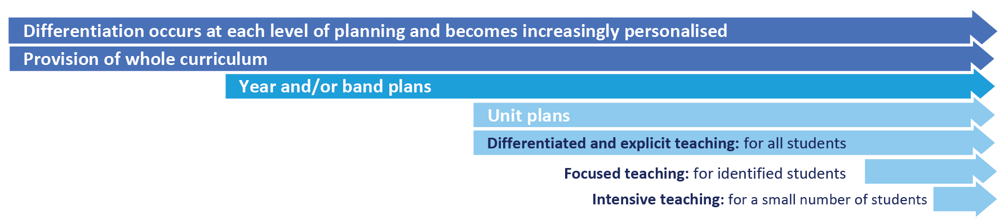

Focused Teaching

Approximately 15% of all students in any school or classroom may require additional support to meet behaviour expectations, even after being provided with differentiated and explicit teaching. These students may have difficulty meeting behavioural expectations in a particular period of the day or as part of a learning area/subject, and focused teaching is provided to help them achieve success.

Focused teaching involves revisiting key behavioural concepts and/or skills and using explicit and structured teaching strategies in particular aspects of a behaviour skill. Focused teaching provides students with more opportunities to practise skills and multiple opportunities to achieve the intended learning and expected behaviour.

Intensive Teaching

Research evidence shows that even in an effective, well-functioning school there will always be approximately 5% of the student population who require intensive teaching to achieve behavioural expectations. Intensive teaching involves frequent and explicit instruction, with individuals or in small groups, to develop mastery of basic behavioural concepts, skills and knowledge.

Some students may require intensive teaching for a short period, for particular behaviour skills. Other students may require intensive teaching for a more prolonged period. Decisions about the approach will be made based on data collected from their teacher or teachers, and following consultation with the student’s family. It will also vary on the length of time the student is attending Ocean Outdoor Environmental Education Centre

Students who require intensive teaching and support will have this support organised by the school at which they are enrolled to ensure that their participation and engagement is maximised.

Disciplinary Consequences

The disciplinary consequences model used at Ocean Outdoor Environmental Education Centre follows the same differentiated approach used in the proactive teaching and support of student behavioural expectations.

The majority of students will be confident and capable of meeting established expectations that are clear, explicitly taught and practised. Corrective feedback, sanctions and rule reminders may be used by teachers to respond to low-level or minor problem behaviours.

Some students will need additional support, time and opportunities to practise expected behaviours. Approximately 15% of the student population may experience difficulty with meeting the stated expectations, and even with focussed teaching, corrective feedback, sanctions and rule reminders continue to display low-level problem behaviour. A continued pattern of low-level behaviour can interfere with teaching and learning for other students, and a decision may be needed by a teacher to refer the student to the principal of Ocean Outdoor Environmental Education Centre for determination of a disciplinary consequence.

On occasion the behaviour of a student may be so serious, such as causing harm to other students or to staff, that the principal of Ocean Outdoor Environmental Education Centre will contact the principal of the school at which the student is enrolled to convey the concerns and advise of the need for the student’s time at Ocean Outdoor Environmental Education Centre to end. If the principal of Ocean Outdoor Environmental Education Centre is unable to reach the principal, for example on a weekend, then the parents of the student may be called and asked to collect their child. Usually this course of action is only taken when the behaviour is either so serious as to warrant immediate removal of the student for the safety of others, and no other alternative discipline strategy is considered sufficient to deal with the problem behaviour.

The differentiated responses to problem behaviour can be organised into three tiers, with increasing intensity of support and consequences to address behaviour that endangers others or causes major, ongoing interference with centre operations.

Differentiated

Teacher provides disciplinary responses to low-level or minor problem behaviour. This may include:
- Pre-correction (e.g. “Remember, walk quietly to your seat”)
- Non-verbal and visual cues (e.g. posters, hand gestures)
- Whole class practising of routines
- Ratio of 5 positive to 1 negative commentary or feedback to class
- Corrective feedback (e.g. “Hand up when you want to ask a question”)
- Rule reminders (e.g. “When the bell goes, stay seated until I dismiss you”)
- Explicit behavioural instructions (e.g. “Put your bag on the rack”)
- Proximity control
- Tactical ignoring of inappropriate behaviour while acknowledging something positive about the student’s behaviour
- Revised seating and relocation of student/s
- Individual positive reinforcement for appropriate behaviour
- Class incentives
- Reminders of incentives or class goals
- Redirection
- Low voice and tone for individual instructions
- Give 30 second ‘take-up’ time for student/s to process instruction/s
- Reduce verbal language
- Break down tasks into smaller chunks
- Provide positive choice of task order (e.g. “Which one do you want to start with?”)
- Prompt student to take a break or time away in class
- Model appropriate language, problem solving and verbalise thinking process (e.g. “I’m not sure what is the next step, who can help me?”)
- Provide demonstration of expected behaviour
- Peer consequence (e.g. corrective feedback to influential peer demonstrating same problem behaviour)
- Private discussion with student about expected behaviour
- Reprimand for inappropriate behaviour
- Warning of more serious consequences (e.g. removal from activity)

Focused

Teacher is supported by other staff to address problem behaviour. This may include:
- Individual student behaviour support strategies (e.g. Student behaviour plan)
- Targeted skills teaching in small group
- Token economy
- Behavioural contract
- Counselling and guidance support
- Self-monitoring plan
- Check in Check Out strategy
- Teacher coaching and debriefing

Intensive

Centre leadership team work in collaboration with teachers from the student’s school to address persistent or ongoing serious problem behaviour. Given the unique setting of Ocean Outdoor Environmental Education Centre, and need to prioritise safety and wellbeing of all students and staff, students who require ongoing intensive support will be largely supported by staff from the school at which they are enrolled.

Any serious incidents will be immediately referred by the principal of Ocean Outdoor Environmental Education Centre to the principal of the student’s school for appropriate school disciplinary action in line with the Student Code of Conduct for that school. This may include suspension or exclusion from school.

Students who attend Ocean Outdoor Environmental Education Centre are not enrolled at the centre, and therefore decisions about the use of a school disciplinary absence, such as suspension or exclusion remain the responsibility of the principal of the school at which the student is enrolled. However, the principal of Ocean Outdoor Environmental Education Centre can end the student’s participation in activities or the program at Ocean Outdoor Environmental Education Centre. It would then be the responsibility of the student’s school principal to address any further disciplinary action.

Centre Policies

Ocean Outdoor Environmental Education Centre has tailored discipline policies designed to ensure students, staff and visitors work cooperatively to create and maintain a supportive and safe learning environment. Please ensure that you familiarise yourself with the responsibilities for students, staff and visitors outlined in the following policies:
- Temporary removal of student property
- Use of mobile phones and other devices by students
- Preventing and responding to bullying
- Appropriate use of social media

Temporary removal of student property

The removal of any property in a student’s possession may be necessary to promote the caring, safe and supportive learning environment of the centre, to maintain and foster mutual respect between all centre staff and students. The Temporary removal of student property by school staff procedure outlines the processes, conditions and responsibilities for state school principals and school staff when temporarily removing student property.

Please be aware that items that are not permitted at Ocean Outdoor Environmental Education Centre may differ from those at the school at which visiting students are enrolled.

In determining what constitutes a reasonable time to retain student property, the centre staff will consider:
- the condition, nature or value of the property
- the circumstances in which the property was removed
- the safety of the student from whom the property was removed, other students or staff members
- good management, administration and control of the centre.

The principal of the centre determines when the temporarily removed student property can be returned, unless the property has been handed to the Queensland Police Service.

The following items are explicitly prohibited at Ocean Outdoor Environmental Education Centre and will be removed if found in a student’s possession:
- illegal items or weapons (e.g. guns, knives*, throwing stars, brass knuckles, chains)
- imitation guns or weapons
- potentially dangerous items (e.g. blades, rope)
- drugs** (including tobacco)
- alcohol
- aerosol deodorants or cans (including spray paint)
- explosives (e.g. fireworks, flares, sparklers)
- flammable solids or liquids (e.g. fire starters, mothballs, lighters)
- poisons (e.g. weed killer, insecticides)
- inappropriate or offensive material (e.g. racist literature, pornography, extremist propaganda).

* The following items are not permitted at Ocean Outdoor Environmental Education Centre, including flick knives, ballistic knives, sheath knives, push daggers, trench knives, butterfly knives, star knives, butter knives, fruit knives or craft knives, or any item that can be used as a weapon, for example a chisel.

Students are permitted to bring cutlery, and Ocean Outdoor Environmental Education Centre will provide information about the procedures for carrying and storing these items while on site.

** The administration of medications to students by centre staff is only considered when a prescribing health practitioner has determined that it is necessary or when there is no other alternative in relation to the treatment of a specific health need. Medical authorisation is required to administer any medication to students (including over-the-counter medications such as paracetamol or alternative medicines).

Responsibilities

Staff at Ocean Outdoor Environmental Education Centre:
- do not require the student’s consent to search centre property such as lockers, desks or laptops that are supplied to the student through Ocean Outdoor Environmental Education Centre;
- may seize a student’s bag where there is suspicion that the student has a dangerous item (for example, a knife) in their bag, prior to seeking consent to search from a parent or calling the police;
- consent from the student or parent is required to examine or otherwise deal with the temporarily removed student property. For example, staff who temporarily remove a mobile phone from a student are not authorised to unlock the phone or to read, copy or delete messages stored on the phone;
- there may, however, be emergency circumstances where it is necessary to search a student’s property without the student’s consent or the consent of the student’s parents (e.g. to access an EpiPen for an anaphylactic emergency);
- consent from the student or parent is required to search the person of a student (e.g. pockets or shoes). If consent is not provided and a search is considered necessary, the police and the student’s parents should be called to make such a determination.

Parents of students attending Ocean Outdoor Environmental Education Centre
- ensure your children do not bring property onto centre grounds or other settings used by the sites (e.g. camp, sporting venues) that:
  - is prohibited according to the Ocean Outdoor Environmental Education Centre Student Code of Conduct
  - is illegal
  - puts the safety or wellbeing of others at risk
  - does not preserve a caring, safe, supportive or productive learning environment
  - does not maintain and foster mutual respect;
- collect temporarily removed student property as soon as possible after they have been notified by the principal or centre staff that the property is available for collection.

Students attending Ocean Outdoor Environmental Education Centre
- do not bring property onto the grounds or other settings used by the centre (e.g. camp, sporting venues) that:
  - is prohibited according to the Ocean Outdoor Environmental Education Centre Student Code of Conduct
  - is illegal
  - puts the safety or wellbeing of others at risk
  - does not preserve a caring, safe, supportive or productive learning environment
  - does not maintain and foster mutual respect;
- collect their property as soon as possible when advised by the principal or centre staff it is available for collection.

Use of mobile phones and other devices by students

Digital literacy refers to the skills needed to live, learn and work in a society where communication and access to information is dominated by digital technologies like mobile phones. However, the benefits brought about through these diverse technologies can be easily overshadowed by deliberate misuse which harms others or disrupts learning.

Ocean Outdoor Environmental Education Centre has determined that no mobile phones, laptops, tablets or smart watches are permitted by students while in attendance at our site. There may be exceptional circumstances where student medical needs necessitate the use of one or more of these devices, and this should be discussed and a decision documented in advance of the student attending Ocean Outdoor Environmental Education Centre.

The Temporary removal of student property policy will apply for all other students who bring mobile phones, laptops, tablets or smart watches to Ocean Outdoor Environmental Education Centre.

Preventing and responding to bullying

Ocean Outdoor Environmental Education Centre uses the Australian Student Wellbeing Framework to promote positive relationships and the wellbeing of all students, staff and visitors at the centre.

Our staff know student learning is optimised when they feel connected to others and experience safe and trusting relationships. Students who feel secure are more likely to be active participants in their learning and to achieve better physical, emotional, social and educational outcomes. Teachers who feel valued and supported are more likely to engage positively with students and build stronger connections within the centre community. Parents who are positively engaged with their child’s education leads to improved student self-esteem, attendance and behaviour at centre. Enhancing the wellbeing of students and their educators delivers overall long-term social, health and economic benefits to the Australian community.

The agreed national definition for Australian schools describes bullying as
- ongoing and deliberate misuse of power in relationships through repeated verbal, physical and/or social behaviour that intends to cause physical, social and/or psychological harm;
- involving an individual or a group misusing their power, or perceived power, over one or more persons who feel unable to stop it from happening;
- happening in person or online, via various digital platforms and devices and it can be obvious (overt) or hidden (covert). Bullying behaviour is repeated, or has the potential to be repeated, over time (for example, through sharing of digital records);
- having immediate, medium and long-term effects on those involved, including bystanders. Single incidents and conflict or fights between equals, whether in person or online, are not defined as bullying.

Behaviours that do not constitute bullying include:
- mutual arguments and disagreements (where there is no power imbalance)
- not liking someone or a single act of social rejection
- one-off acts of meanness or spite
- isolated incidents of aggression, intimidation or violence.

However, these conflicts are still considered serious and need to be addressed and resolved. At Ocean Outdoor Environmental Education Centre our staff will work to quickly respond to any matters raised of this nature in collaboration with students and parents.

The following flowchart explains the actions Ocean Outdoor Environmental Education Centre teachers will take when they receive a report about student bullying, including bullying which may have occurred online or outside of the centre setting. Please note that the indicative timeframes will vary depending on the professional judgment of teachers who receive the bullying complaint and their assessment of immediate risk to student/s.

Ocean Outdoor Environmental Education Centre - Bullying response flowchart for teachers

Please note these timelines may be adjusted depending on the unique circumstances and risk associated with each situation. This is at the professional judgment of the staff involved. Timeframes should be clearly discussed and agreed with student and family.
Key contacts for students and parents to report bullying:
Staff member title – Name – Phone number
Staff member title – Name – Phone number
Staff member title – Name – Phone number

SHORT TERM
1
- Provide a safe, quiet space to talk
- Reassure the student that you will listen to them
- Let them share their experience and feelings without interruption
- If you hold immediate concerns for the student's safety, let the student know how you will address these. Immediate in this circumstance is where the staff member believes the student is likely to experience harm (from others or self)
Cyberbullying
LONGER TERM
- Evaluate the information to determine if bullying has occurred or if another disciplinary matter is at issue
- Make a time to meet with the student to discuss next steps
- Ask the student what they believe will help address the situation
- Engage the student as part of the solution
- Agree to a plan of action and timeline for the student
4
- If student is continuing a longer term program at Ocean Outdoor Environmental Education Centre:
- Gather additional information from other students and staff
- Make sure you can answer who, what, where, when and how
- Clarify information with student and check on their wellbeing
3
- Document the plan of action
- Complete all actions agreed with student within agreed timeframes
- Monitor student and check in regularly on their wellbeing
- Seek assistance from student’s regular centre staff as needed
5
- Ask the student for examples they have of the alleged bullying (e.g. hand written notes or screenshots)
- Write a record of your communication with the student
- Check back with the student to ensure you have the facts correct
- Advise the staff of the student’s school immediately and document call or email
- Ensure parent/s are notified the issue of concern is being investigated
2
Cyberbullying is treated at Ocean Outdoor Environmental Education Centre with the same level of seriousness as in-person bullying.

It is important for students, parents and staff to know that state school principals have the authority to take disciplinary action to address student behaviours that occur outside of school hours or school grounds. This includes cyberbullying. Parents and students who have concerns about cyberbullying incidents occurring during school holidays should immediately seek assistance through the Office of the e-Safety Commissioner or the Queensland Police Service.

Students attending Ocean Outdoor Environmental Education Centre may face disciplinary action, such as removal from activity or removing of privileges, or more serious consequences such as referral to their regular school principal for consideration of suspension or exclusion from school for engaging in behaviour that adversely affects, or is likely to adversely affect, other students or the good order and management of the school. This includes behaviour such as cyberbullying which occurs outside of school hours or settings, for example on the weekend or during school holidays. It also applies to inappropriate online behaviour of enrolled students that is directed towards other community members or students from other school sites.

Parents or other stakeholders who engage in inappropriate online behaviour towards students, staff or other parents may be referred to the Office of the e-Safety Commissioner and/or the Queensland Police Service. Centre staff will be referred for investigation to the Integrity and Employee Relations team in the Department of Education. Any questions or concerns about the Ocean Outdoor Environmental Education Centre process for managing or responding to cyberbullying should be directed to XXXXX.

Ocean Outdoor Environmental Education Centre - Cyberbullying response flowchart for staff

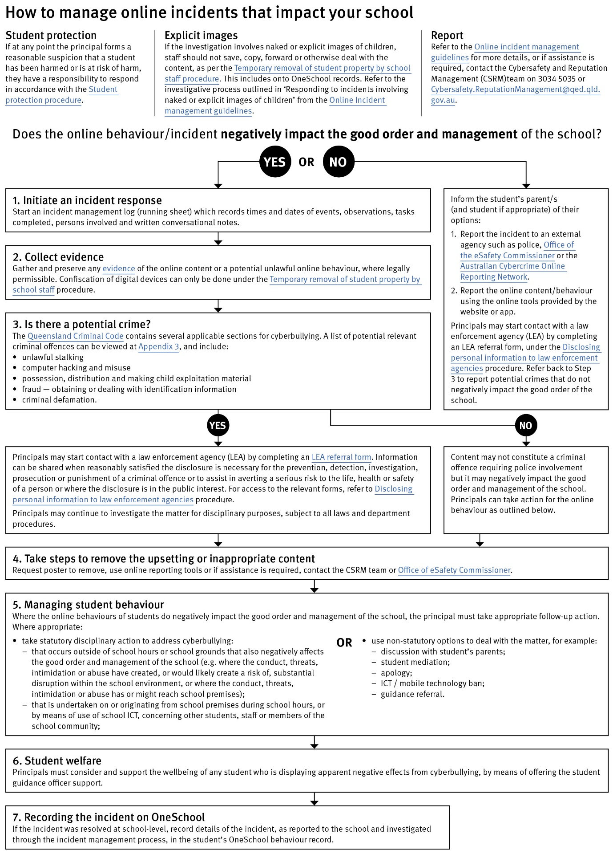

Cybersafety and Reputation Management (CRM)

The Department of Education employs a dedicated team of experts to assist in maintaining the integrity of the department's reputation with regards to cybersafety and reputation management issues, effectively leading the development and implementation of departmental cybersafety processes.

This team provides direct support to respond to concerns of inappropriate online behaviour and misuse of information and communication technology.

The team provides a guide for parents with important information about cybersafety and cyberbullying, and suggestions about what you can do if your child is a target or responsible for inappropriate online behaviour.

The team has also developed a Cyberbullying and reputation management (Department employees only) resource to assist principals in incident management.

For more information about cybersafety sessions at your centre, or for assistance with issues relating to online behaviour, contact the team (Department employees only).

Appropriate use of social media

The internet, mobile phones and social media provide wonderful opportunities for students to network and socialise online. While these technologies provide positive platforms for sharing ideas, they also have the potential to cause pain and suffering to individuals, groups or even whole communities.

It’s important to remember that sometimes negative comments posted about the centre community have a greater impact than expected. This guide offers some information about how to use social media in relation to comments or posts about the centre community. Reputations of students, teachers, centres, principals and even parents can be permanently damaged — and in some cases, serious instances of inappropriate online behaviour are dealt with by police and the court system.

Being aware of a few simple strategies can help keep the use of social media positive and constructive:
- Before you post something online, ask yourself if the community or individual really need to know. Is it relevant, positive and helpful?
- Remember that what you post online is a direct reflection of who you are. People will potentially form lasting opinions of you based on what you post online.
- Be a good role model. If things get heated online consider logging out and taking a few moments to relax and think. Hasty, emotive responses could inflame situations unnecessarily.
- Be mindful when commenting, try to keep general and avoid posting anything that could identify individuals.
- A few years ago parents may have discussed concerns or issues with their friends at the school gate. Today with the use of social media, online discussions between you and your close friends can very quickly be shared with a much wider audience, potentially far larger than intended.
- Taking a few moments to think about the content you are about to post could save upset, embarrassment, and possible legal action.
- As a parent you have a role in supervising and regulating your child’s online activities at home and its impact on the reputation and privacy of others. Parents are their child’s first teachers — so they will learn online behaviours from you.

Is it appropriate to comment or post about centres, staff or students?

Parental and community feedback is important for us and the department. If you have a compliment, complaint or enquiry about an issue at the centre, the best approach is to speak directly to the centre about the matter, rather than discussing it in a public forum.

While many centres use social media to update parents of notices, the department prefers that parents contact centres directly with a compliment, complaint or enquiry due to privacy considerations. Imagine if your doctor, accountant or banking institution tried to contact you to discuss important matters via Facebook.

If you have raised an issue with a centre or know that another person has, consider refraining from discussing those details on social media, particularly the names of anyone involved.

Keep comments calm and polite, just as you would over the telephone or by email. If you encounter negative or derogatory content online which involves the centre, hinders a child’s learning and/or affects the centre community at large, contact the principal.

Possible civil or criminal ramifications of online commentary

A serious instance of inappropriate online behaviour may constitute a criminal offence and become a police matter. For example, online content may substantiate the offence of ‘using a carriage service to menace, harass or cause offence’ (Criminal Code Act 1995 (Cth) s. 474.17). School staff may contact their union or obtain personal legal advice if they feel that online content seriously impacts their reputation. Defamatory online content may give rise to litigation under the Defamation Act 2005 (Qld).

What about other people’s privacy?

If you upload photos of your children, be mindful of who might be in the background. You might be happy to share your child’s successes with your friends and family via social media, but some parents are not. If you are tagging or naming students, consider that other parents may not want their child’s name attached to images online.

What if I encounter problem content?

Taking the following steps may help resolve the issue in a constructive way:
- refrain from responding
- take a screen capture or print a copy of the concerning online content
- if you consider problem content to be explicit, pornographic or exploitative of minors, you should keep a record of the URL of the page containing that content but NOT print or share it. The URL can be provided to the principal, or police, as needed for escalation of serious concerns
- block the offending user
- report the content to the social media provider.

Cyberbullying response flowchart for Ocean Outdoor Environmental Education Centre
Liaise with base school principals where there is a student protection concern or where there is any other significant concern.

How to manage online incidents

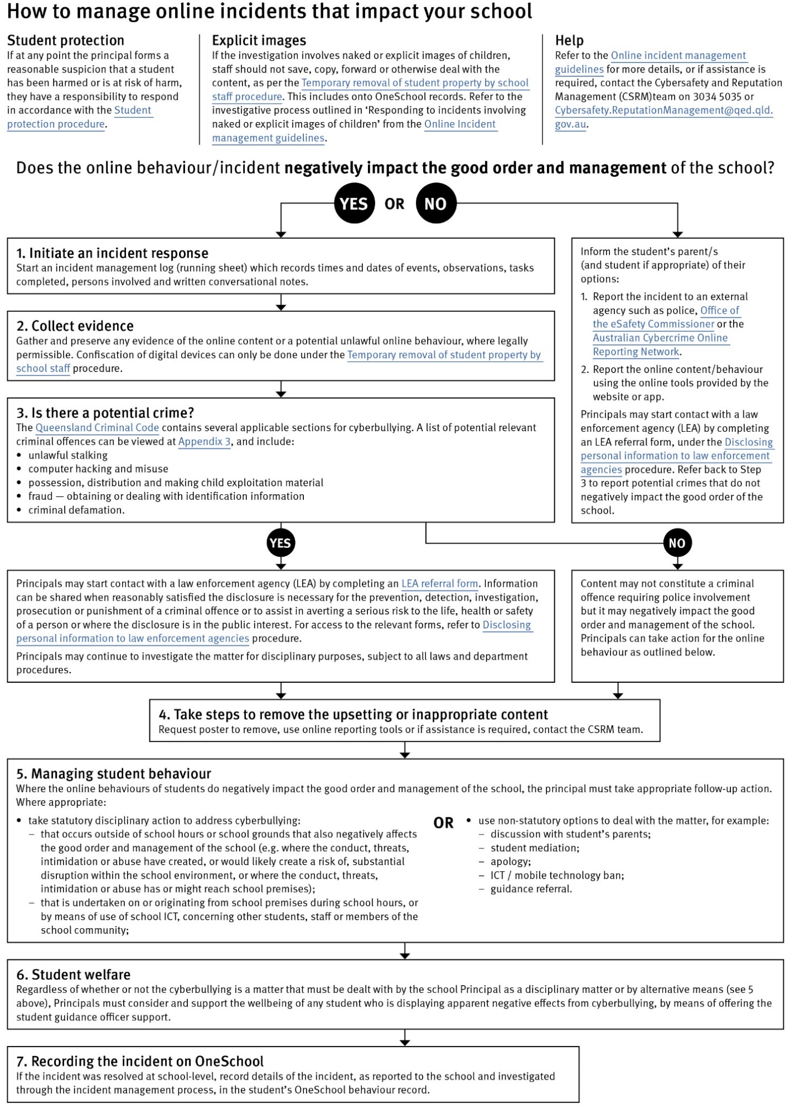
Restrictive Practices
Staff at Ocean Outdoor Environmental Education Centre need to respond to student behaviour that presents a risk of physical harm to the student themselves or others. It is anticipated that most instances of risky behaviour can be de-escalated and resolved quickly. On some rarer occasions, a student’s behaviour may continue to escalate and staff need to engage immediately with positive and proactive strategies aimed at supporting the student to manage their emotional arousal and behaviour.

In some very rare situations, where there is immediate risk of physical harm to the student or other people, and when all other alternative strategies have failed to reduce the risk, it may be necessary for staff to use restrictive practices.

The use of restrictive practices will always be as a last resort, when there is no other available option for reducing immediate risk to the student, staff or other people. Restrictive practices are not used for punishment or as a disciplinary measure.

The department’s Restrictive practices procedure is written with consideration for the protection of everyone’s human rights, health, safety and welfare. There are six fundamental principles:

- Regard to the human rights of those students
- Safeguards students, staff and others from harm
- Ensures transparency and accountability
- Places importance on communication and consultation with parents and carers
- Maximises the opportunity for positive outcomes, and
- Aims to reduce or eliminate the use of restrictive practices.

Very rarely restrictive practices will be planned and staff will employ, when necessary, pre-arranged strategies and methods (of physical restraint/ mechanical restraint/ clinical holding) which are based upon behaviour risk assessment or clinical health need and are recorded in advance. The use of planned strategies will only be where there is foreseeable immediate risk consistent with the Restrictive practices procedure.

Seclusion will not be used as a planned response and will only be used in serious circumstances for managing an unforeseeable situation in an emergency. It will be used for the shortest time possible and in a safe area that presents no additional foreseeable risk to the student. In such emergencies, a staff member will observe the student at all times and seclusion will cease as soon as possible.

Following the use of any restrictive practice, a focused review will help staff to understand how they responded to the risk in any incident that involved the use of a restrictive practice. Staff will consider whether there are other options for managing a similar situation in the future. This strategy works well for reducing the use of restrictive practices.

All incidents of restrictive practices will be recorded and reported in line with departmental procedures.
Critical Incidents

Residential attendance and the remote location are two unique factors that must be considered in an appropriate response to an emergency, critical incident or severe problem behaviour. Students are in residential attendance at Ocean Outdoor Environmental Education Centre, 24 hours a day, for the duration of their program, some of which may be conducted in remote, isolated locations.

It is important that all staff have a consistent understanding of how to respond in emergencies involving student behaviour that seriously endangers the student or others. This consistency ensures that appropriate actions are taken to ensure that both students and staff are kept safe.

A critical incident is defined as an occurrence that is sudden, urgent, and usually unexpected, or an occasion requiring immediate action (e.g. in the community, on the road). The aim in these situations is to bring the behaviour of the student under rapid and safe control. It is not a time to try and to punish or discipline the student; it is a crisis management period only.

Staff should follow the documented plan for any student involved in regular critical incidents, which should be saved and available for staff to review.

For unexpected critical incidents, staff should use basic defusing techniques:

- Avoid escalating the problem behaviour: Avoid shouting, cornering the student, moving into the student’s space, touching or grabbing the student, sudden responses, sarcasm, becoming defensive, communicating anger and frustration through body language.

- Maintain calmness, respect and detachment: Model the behaviour you want students to adopt, stay calm and controlled, use a serious measured tone, choose your language carefully, avoid humiliating the student, be matter of fact and avoid responding emotionally.

- Approach the student in a non-threatening manner: Move slowly and deliberately toward the problem situation, speak privately to the student/s where possible, speak calmly and respectfully, minimise body language, keep a reasonable distance, establish eye level position, be brief, stay with the agenda, acknowledge cooperation, withdraw if the situation escalates.

- Follow through: If the student starts displaying the appropriate behaviour briefly acknowledge their choice and re-direct other students’ attention towards their usual work/activity. If the student continues with the problem behaviour, then remind them of the expected behaviour and identify consequences of continued unacceptable behaviour.

- Debrief: At an appropriate time when there is low risk of re-escalation, help the student to identify the sequence of events that led to the unacceptable behaviour, pinpoint decision moments during the sequence of events, evaluate decisions made, and identify acceptable decision options for future situations.

